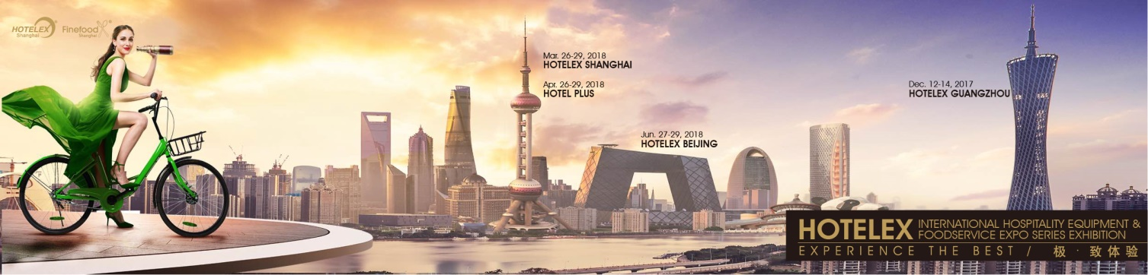

Complete the form below to get yourself carried away to a broader business field (asterisk is mandatory):
Exhibitor Profile
*Country/Region Hong Kong Macao Taiwan Other country Visitors from Mainland China, please register here
* Company Name
* Job Title
* Address
Postal Code
Website
* First name
* Last Name
* E-mail
* Mobile
Telephone

Business Nature
Catering Equipment Supply
Tableware
Cooking Ingredient
Coffee & Appliance and Supply
Bakery
Ice Cream
Beverage
Wine & Spirits
Textile
Appliance Amenities
IT & Security
Fitness & Leisure
Build Decoration
Interior Design
Engineering & Design
Lighting & Intelligence
Hotel Furniture
Hotel Clean
Others, (please specify)

Your Interested Buyer Profile
Hotel/Motel/Resort
Restaurant/Fast-food Outlet/Snack Bar/Take-away
Club/Sports Centre/Theme Park/Leisure Centre/Theater
OK Pub/Bar/Night Club/Karaoke Bar
Catering/Hospitals/Government/Institutions/Airlines/Contract/Cruise Lines/Factory
Café/Tea House
Department Store/Duty Free Shop/Supermarket/Hypermarket/Grocery Store/Convenient Store
Chains/Franchising
Ice Cream/Chocolates/Sweets
Bread/Bakery Store/Pizza Store
Food & Beverage Importer & Exporter
Hotel Supplies Manufacturer
Food & Beverage Manufacturer
Hotel Supplies Importer & Exporter/Distributor
Real Estate/Design Company
Distributor
End User
Procurement
Strategic Sourcing
Global Sourcing
Retailer
Merchandising
Fast-Moving Consumer Goods (FMGG)
Agents
Delegates
E-business
Media
Others, (please specify)

- Onsite Matchmaking Meeting Schedule
Preferred Date:
Preferred Time:
Company:
Contact:
E-mail:
Booth Number:

YOU ARE HERE
1

3
2

STEP 3
Schedule
On-site meetings

STEP 4
E-mail
your form

STEP 2
View/Edit
your profile

STEP 2
Download
your profile

Registration in Matchmaking System starts in advance and lasts until the exhibition is over. Please send your form to the following contacts and should your inquiry be responded to as soon as possible.
Alex.ni@ubmsinoexpo.com
Sukie.li@ubmsinoexpo.com

